- Daviess County Library • May 2022
Sunday | Monday | Tuesday | Wednesday | Thursday | Friday | Saturday
1 | 2 | 3 | 4  FSU Livestream & Intro to SRP  @Gallatin K-2 9:30am | 5  FSU Livestream & Intro to SRP  @Gallatin 3-4 12:30pm  @Pattonsburg 12:30pm | 6 | 7
8 | 9 | 10 | 11 | 12 | 13  FSU Livestream & Intro to SRP  North Daviess @ DCL  9-11:00am . | 14
15 | 16 | 17 | 18 | 19 | 20 | 21
22  CHILDREN’S PROGRAM  -KICK OFF WEEK | 23 | 24  SRP Registration Begins  9am-6pm | 25  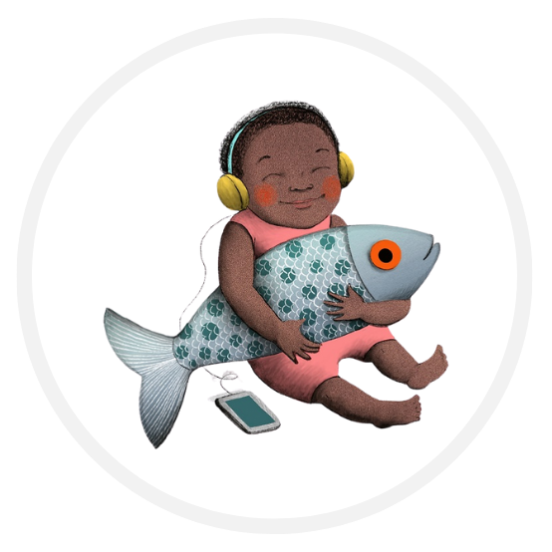BOOKMOBILE | 26  BINGO @Library  10am | 27  STORYTIME @ Aquarium (Castle)  10am | 28
29  CHILDREN’S PROGRAM  -OCEAN WEEK | 30 | 31 |  |  |  | 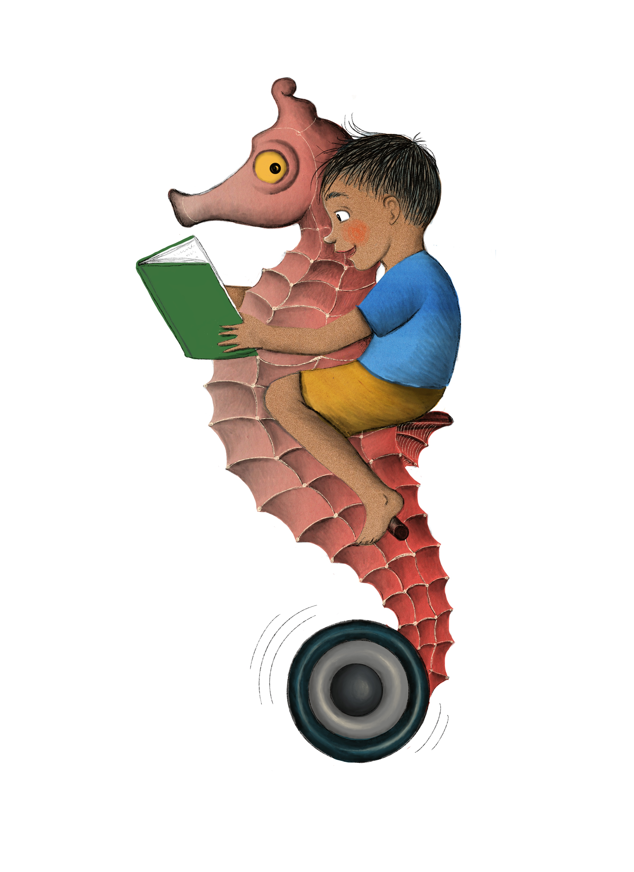
*Each program attended gets your name entered for the prize drawings. The more you participate, the more entries!
- Daviess County Library • June 2022
Sunday | Monday | Tuesday | Wednesday | Thursday | Friday | Saturday
CHILDREN’S PROGRAM  -OCEAN WEEK |  |  | 1  BOOKMOBILE | 2  BINGO @Library  10am | 3  STORYTIME @ Aquarium (Castle)  10am | 4
5  CHILDREN’S PROGRAM  -PIRATE WEEK | 6 | 7  Pirate Show @ Library  10am  12:30pm | 8  BOOKMOBILE | 9  BINGO @Library  10am | 10  STORYTIME @ Aquarium (Castle)  10am | 11
12  CHILDREN’S PROGRAM  -MERMAID WEEK | 13 | 14  Petting Zoo @ Library  10am-noon | 15  BOOKMOBILE | 16  BINGO @Library  10am | 17  STORYTIME @ Aquarium (Castle)  10am | 18
19  CHILDREN’S PROGRAM-  CREATURE WEEK | 20 | 21  S.T.E.A.M @  Library  10am-11am | 22  BOOKMOBILE | 23  BINGO @Library  10am | 24  STORYTIME @ Aquarium (Castle)  10am | 25
26  CHILDREN’S PROGRAM  -SHARK WEEK | 27 | 28 | 29  BALLOON ARTIST  @ Winston Park  10am | 30  Conservation Agent @Library  10am
*Each program attended gets your name entered for the prize drawings. The more you participate, the more entries!
** Registration continues all summer. Goody bags with registration, while supplies last.

- Daviess County Library • July 2022
Sunday | Monday | Tuesday | Wednesday | Thursday | Friday | Saturday
 |  |  |  |  | 1  STORYTIME @ Aquarium (Castle)  10am | 2
3  ADULT/TEEN PROGRAM  -PHOTO CONTEST | 4 | 5  ADULT EXERCISE  2pm | 6  BOOKMOBILE | 7  ADULT EXERCISE  2pm | 8  STORYTIME @ Aquarium (Castle)  10am  ADULT COMPUTER SEMINAR 1pm | 9  ADULT KICK OFF PARTY 9-noon  PHOTOGRAPHY CLASS  10-11am
10  ADULT/TEEN PROGRAM  -TINY ART | 11 | 12  TINY ART CLASS  10am  ADULT EXERCISE  2pm | 13  TINY ART STUDIO OPEN  BOOKMOBILE | 14  TINY ART STUDIO OPEN  ADULT EXERCISE  2pm | 15  STORYTIME @ Aquarium (Castle)  10am  ADULT COMPUTER Work Day 1pm | 16  TINY ART DUE @ LIBRARY by NOON
17  ADULT/TEEN  PROGRAM  -SCANNER GENEOLOGY | 18 | 19  FSU Livestream  9:30am – 11:30am @ DCL with Jamesport  ADULT EXERCISE  2pm | 20  BOOKMOBILE | 21  ADULT EXERCISE  2pm  GENEOLOGY CLASS @ LIBRARY 5:30pm | 22  STORYTIME @ Aquarium (Castle)  10am  ADULT COMPUTER SEMINAR 1pm | 23
24/31  ADULT PROGRAM  -CRICUT | 25 | 26  CARD MAKING w/CRICUT 10am  ADULT EXERCISE  2pm | 27  BOOKMOBILE | 28  ADULT EXERCISE  2pm  CARD MAKING w/CRICUT 5:30 | 29  STORYTIME @ Aquarium (Castle)  10am | 30
*Each program attended gets your name entered for the prize drawings. The more you participate, the more entries!
** Registration continues all summer. Goody bags with registration, while supplies last.

- Daviess County Library • August 2022
Sunday | Monday | Tuesday | Wednesday | Thursday | Friday | Saturday
 | 1  *TURN IN READING LOGS AND ENTER DRAWINGS BY AUGUST 13TH | 2  ADULT EXERCISE  2pm | 3 | 4  ADULT EXERCISE  2pm | 5  STORYTIME @ Aquarium (Castle)  10am | 6
7 | 8 | 9  ADULT EXERCISE  2pm | 10 | 11  ADULT EXERCISE  2pm | 12  STORYTIME @ Aquarium (Castle)  10am | 13  **LAST DAY TO RETURN LOGS/ENTER DRAWINGS**  *12PM (NOON)*  ICE CREAM PARTY & PRIZE DRAWINGS
14 | 15 | 16  ADULT EXERCISE  2pm | 17 | 18  ADULT EXERCISE  2pm | 19  STORYTIME @ Aquarium (Castle)  10am | 20
21 | 22 | 23  ADULT EXERCISE  2pm | 24 | 25  ADULT EXERCISE  2pm | 26  STORYTIME @ Aquarium (Castle)  10am | 27
28 | 29 | 30  ADULT EXERCISE  2pm | 31 |  |  | 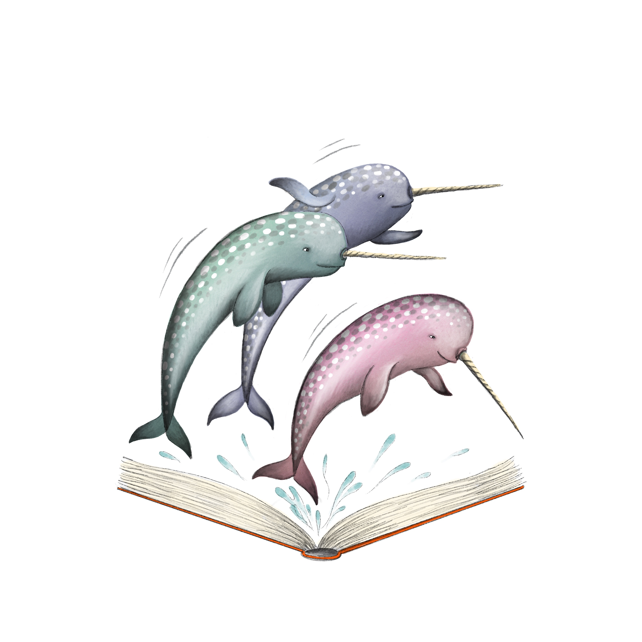
*Each program attended gets your name entered for the prize drawings. The more you participate, the more entries!
** Registration continues all summer. Goody bags with registration, while supplies last.

