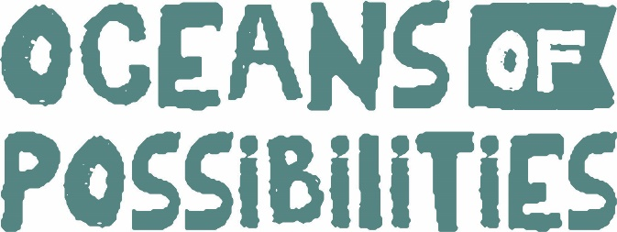

2022 DCL Summer Reading Program
BOOKMOBILE WEDNESDAY
Jameson/Coffey Schedule
May 25th: 10-10:15am Jameson Park
May 25th: 10:45-11am Coffey Park
June 1st: 10-10:15am Jameson Park
June 8th: 10-10:15am Coffey Park
June 15th: 10-10:15am Jameson Park
June 22nd: 10-10:15am Coffey Park
June 29th: SPECIAL PROGRAM – BALLOON ARTIST IN WINSTON @ 10AM
July 6th: 10-10:15am Coffey Park
July 13th: 10-10:15am Jameson Park
July 20th: 10-10:15am Coffey Park
July 27th: 10-10:15am Jameson Park
DCL WILL BE GIVING BOOKS AWAY EACH WEEK AT EACH LOCATION! Come see us each time we are in your location for free books and a take home craft project.
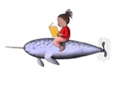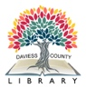
This project is supported by the Institute of Museum and Library Services under the provisions of the Library Services and Technology Act as administered by the Missouri State Library, a division of the Office of the Secretary of State.

2022 DCL Summer Reading Program
BOOKMOBILE WEDNESDAY
Winston/Altamont
May 25th: 1-1:15pm Winston Park
May 25th: 1:45-2:00pm Altamont Park
NO BOOKMOBILE IN THESE LOCATIONS IN JUNE
(Summer School)
July 6th: 1-1:15pm Winston Park
July 13th: 1-1:15pm Altamont
July 20th: 1-1:15pm Winston Park
July 27th: 1-1:15pm Altamont Park
DCL WILL BE GIVING BOOKS AWAY EACH WEEK AT EACH LOCATION! Come see us each time we are in your location for free books and a take home craft project.
This project is supported by the Institute of Museum and Library Services under the provisions of the Library Services and Technology Act as administered by the Missouri State Library, a division of the Office of the Secretary of St

