- Daviess County Library • July 2022
Sunday | Monday | Tuesday | Wednesday | Thursday | Friday | Saturday
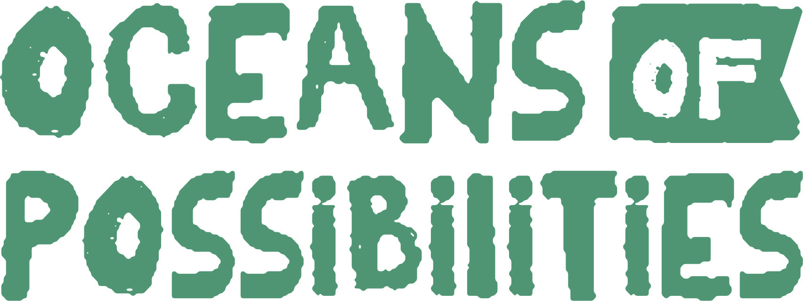 |  |  |  |  | 1  STORYTIME @ Aquarium (Castle)  10am | 2
3  ADULT/TEEN PROGRAM  -PHOTO CONTEST | 4 | 5  ADULT EXERCISE  2pm | 6  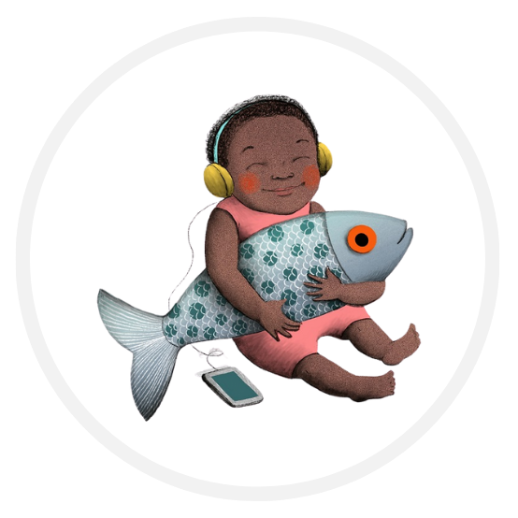BOOKMOBILE | 7  ADULT EXERCISE  2pm | 8  STORYTIME @ Aquarium (Castle)  10am  ADULT COMPUTER SEMINAR 1pm | 9  ADULT KICK OFF PARTY  PHOTOGRAPHY CLASS  10-11am
10  ADULT/TEEN PROGRAM  -TINY ART | 11 | 12  TINY ART CLASS  10am  ADULT EXERCISE  2pm | 13  TINY ART STUDIO OPEN  BOOKMOBILE | 14  TINY ART STUDIO OPEN  ADULT EXERCISE  2pm | 15  STORYTIME @ Aquarium (Castle)  10am  ADULT COMPUTER WORK DAY 1pm | 16  TINY ART DUE @ LIBRARY by NOON
17  ADULT/TEEN  PROGRAM  -SCANNER GENEOLOGY | 18 | 19  FSU Livestream  9:30am – 11:30am @ DCL with Jamesport  ADULT EXERCISE  2pm | 20  BOOKMOBILE | 21  ADULT EXERCISE  2pm  GENEOLOGY CLASS @ LIBRARY 5:30pm | 22  STORYTIME @ Aquarium (Castle)  10am  ADULT COMPUTER SEMINAR 1pm | 23
24/31  ADULT PROGRAM  -CRICUT | 25 | 26  CARD MAKING w/CRICUT 10am  ADULT EXERCISE  2pm | 27  BOOKMOBILE | 28  ADULT EXERCISE  2pm  CARD MAKING w/CRICUT 5:30 | 29  STORYTIME @ Aquarium (Castle)  10am | 30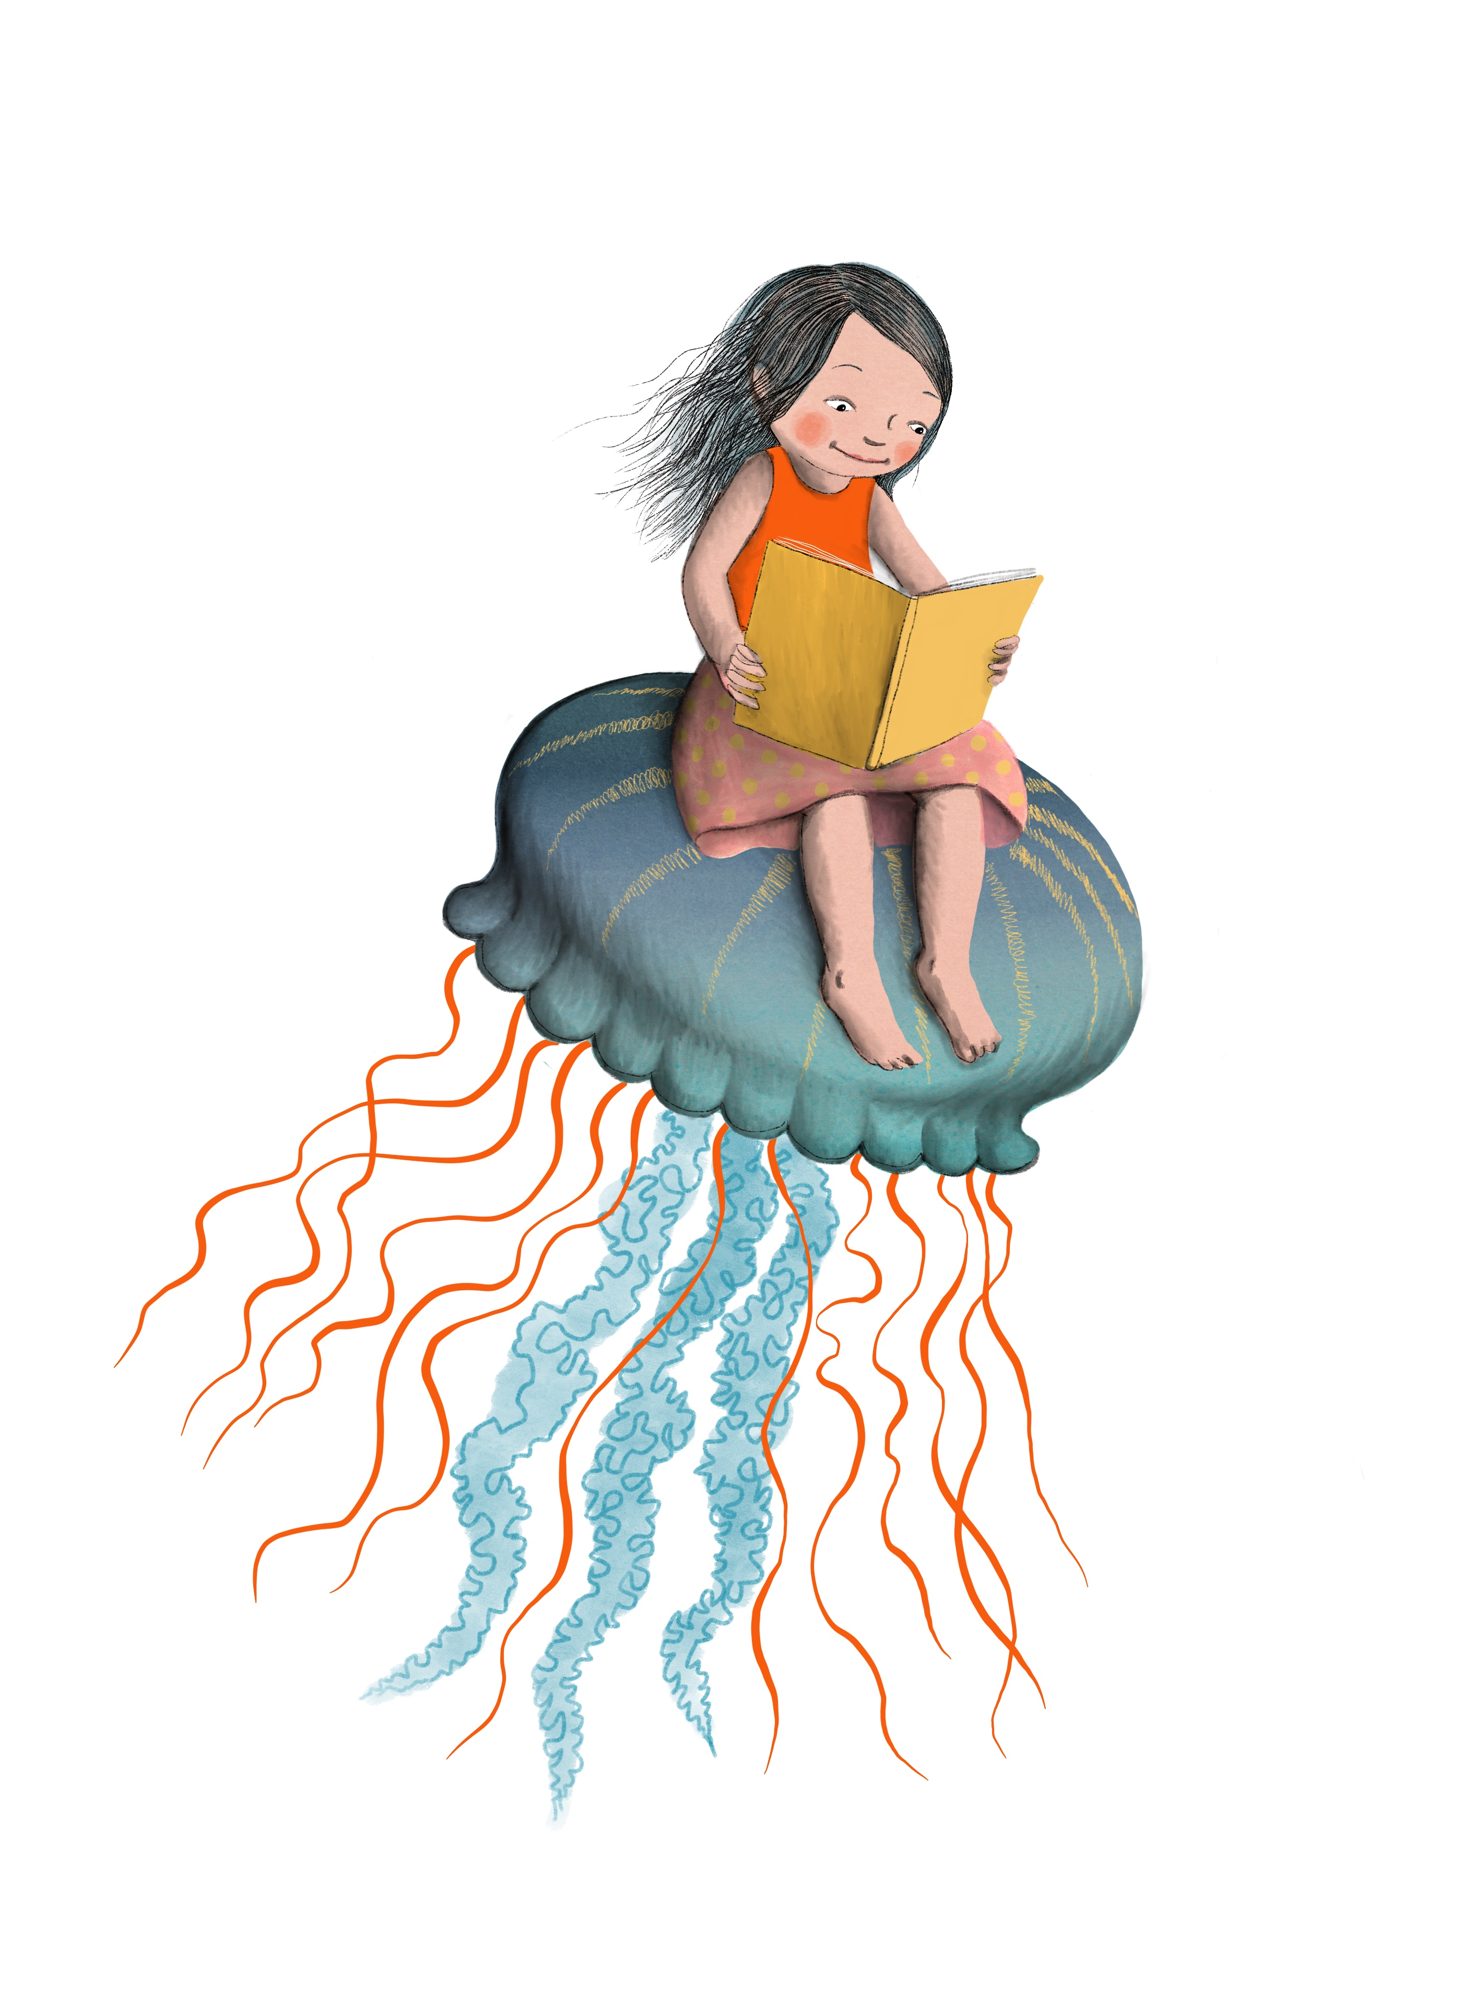
*Each program attended gets your name entered for the prize drawings. The more you participate, the more entries!

